CMS ACTIVITY – 5

The Two things which would like to apply on myself would be grief cycle and medicine wheel. If the question anyone asks me why I will use this application, my answer would be these are the only tool which aids a person to be joyful. Moreover, these tools can only work when one is putting his efforts to get out from the shallow pit or the lows of his sadness (depression).

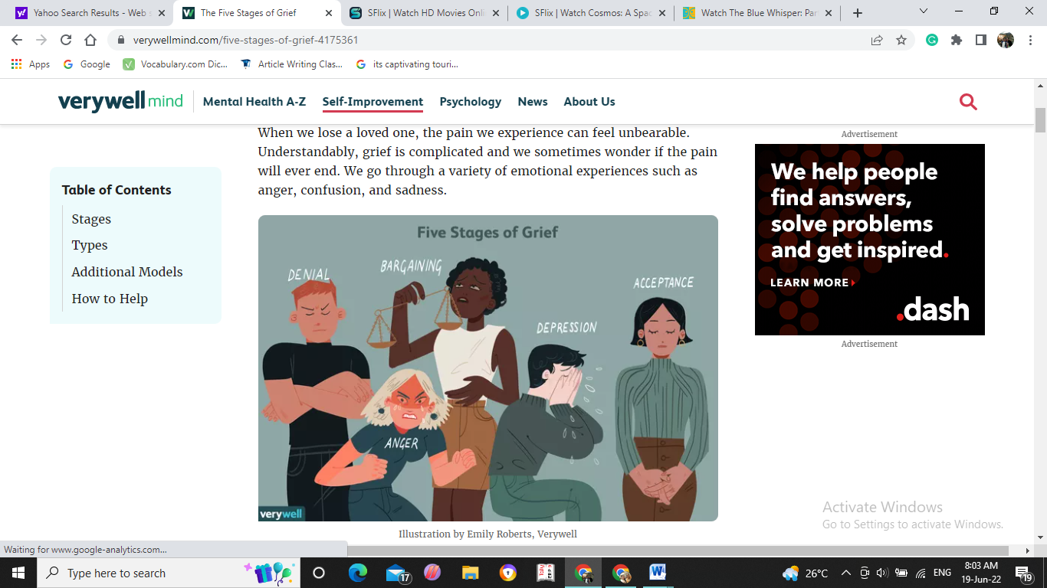

What is grief cycle?

Well, to understand it, it has 5 stages;

initial stage is the **Denial,** it is not only an attempt to pretend that the loss does not exist, adding to this, a human is only trying to absorb and understand what is happening around him at that time. Second is the **Anger,** it is common to experience anger after the loss of a loved one. Moreover, at moment the person is only trying to adjust to a new reality and most likely experience an extreme emotional discomfort.

Third is the **Bargaining**, it is a way to cope up with the loss, it is not unusual to feel so desperate and willing to do almost anything to alleviate or minimize the excruciating pain of losing a loved one as it cause everyone to consider any way to avoid the current pain or the pain anticipating from the loss. There are various ways which may be tried to bargain. 1. “God, if you can heal this person I will turn my life around”. 2. “I promise to be better if you will let this person live”. 3.”I’ll never get angry again if you can cease him/her from dying or leaving me”.

Forth is **Depression,** during to the experience of processing grief, there comes a time when our imaginations calm down and we slowly start to look at the reality of our present situation. Where bargaining is no longer an option and we are faced with what is happening. In those moments, we tend to pull inward as the sadness grows or we might find ourselves retreating, being less sociable, and reaching out less to others about what we are going through. Although this is a very natural stage of grief, dealing with depression after the loss of a loved one can be extremely isolating.

The final state is **Acceptance**, when we come to a place of acceptance; it is not that we no longer feel the pain of loss. However, we are no longer resisting the reality of our situation, and we are not struggling to make it something different. Sadness and regret can still be present in this phase, but the emotional survival tactics of denial, bargaining, and anger is less likely to be present.

What is a medicine wheel?

The medicine wheel (also called the Sun Dance Circle or Sacred Hoop) is **an ancient and sacred symbol used by many Tribes**. It signifies Earth's boundary and all the knowledge of the universe.

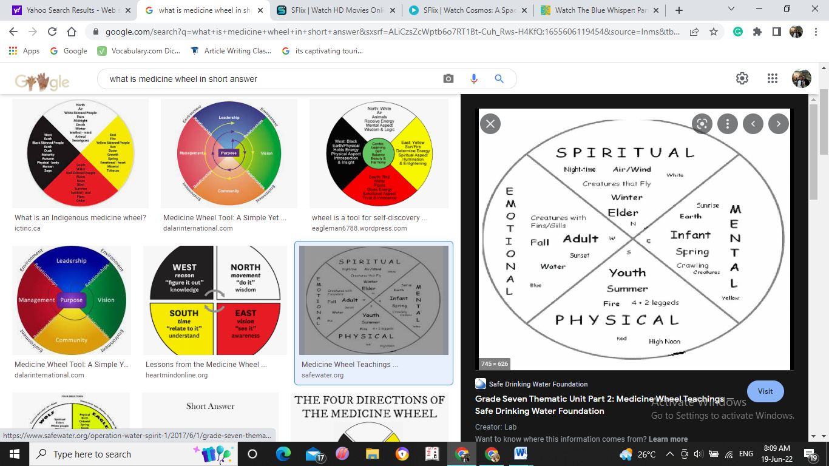In simple terms, it is a balance cycle of a body, which starts from spiritual, emotional, mental and physical balance of a human body.

As far as I am concern, both these tool supported me a lot. To illustrate, primarily in covid pandemic, subsequently, in death of the loved ones, and my exam where I need to use medicine wheel tool to calm down myself.